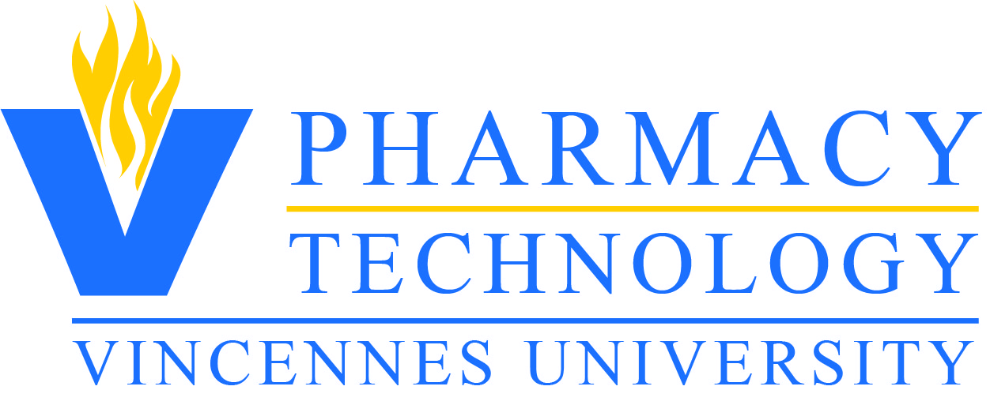
Twin Rivers Information Packet

Website: https://my.vinu.edu/pharmacy-technology
E-mail: ko’connor@vinu.edu
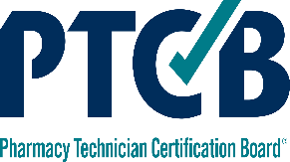
Phone: (812) 888-4470
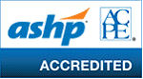
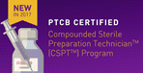
The Vincennes University Pharmacy Technology Program is accredited by the American Society of Health-System Pharmacists, and prepares technicians for the Pharmacy Technician Certification Board’s (PTCB) Pharmacy Technician Certification Exam (PTCE) and also qualifies as a PTCB Certified Compound Sterile Preparation Technician (CSPT) Training Program
@vupharmtech | @vupharmacy | @PharmacyVu

Welcome!!!

Vincennes University
Department of Health Sciences and Human Performance
1002 North 1st Street
Vincennes, IN 47591

Dear Prospective Student:
Thank you for considering enrolling in the Twin Rivers Pharmacy Technician courses at Vincennes University! These courses will prepare you for a wide variety of career opportunities in both the public and the private sector. You will complete concentrated Pharmacy Technology courses which will prepare you to take the PTCB National Certification Exam to become a licensed pharmacy technician.
Once you graduate high school you may want to consider completing necessary general education course to get your Certificate of Graduation or your Associate of Science Degree from Vincennes University.
Please be sure to review the contents of this packet carefully. I am excited about our new partnership and look forward to the opportunity to help you grow and prosper in the exciting world of Pharmacy Technology! Please feel free to contact me at 812-888-4470 or e-mail at ko'connor@vinu.edu. If you have questions regarding admissions please contact Jenny Hooten, Health Sciences Admission & Recruitment Coordinator, 812-888-4243 or e-mail jhooten@vinu.edu.

Sincerely,

Karen M. O'Connor CPhT
Pharmacy Technology, Chair

Application Process
The application process for the Twin Rivers Pharmacy Technology Program is a multi-step process. You will be give information from your Twin Rivers representative regarding requirements and deadlines for Twin Rivers applications. In addition to the Twin Rivers documents, the following are required to complete the application for Pharmacy Technology:
-Completed Vincennes University Application (see page 11)
-Completed Pharmacy Technology Application (see page 12)
-Submit a copy of your high school transcript with application materials
-Complete the Accuplacer/ACT/and or SAT and have scores on file at Vincennes University or submit copy of official test scores. The highest score from all test results will be utilized to determine admission. Applicants that have a minimum cumulative high school GPA of 2.5 (on a standard 4.0 scale) who have completed Algebra II with a grade of C- or better do not have to have Accuplacer scores.
Required Scores:
 | Math | English/Writing | Reading
SAT | 560+ | W 25+ -or-  evidence based R/W 510+ | 23+
ACT | 22+ | English 18+ | 21+
Accuplacer  (next generation) | QAS 245+  AAF 240+ | Reading/Writing 250+

Applications cannot be evaluated until all application materials are on file. All communication from the Pharmacy Technology Program will be sent via email. Please be sure to provide an email address that is frequently checked.
Admission requirements
1. Complete required application requirements
2. Meet test score requirements (placement into English Composition I and MATT 109/107 with
no co-requisite requirement). See comment above regarding high school GPA/Algebra II.
3. Have a high school GPA of 2.3 or higher

Additional Requirements
Student that enroll in pharmacy technology courses at Vincennes University are required to complete a 10 panel drug test, criminal history report, and purchase our medical/clinical tracking software to upload health forms. Information about the process will be sent to applicants that qualify for enrollment. The cost for the drug screen, criminal history report, and medical/clinical tracking software are the student’s responsibility. Estimated costs for all three components is approximately $120.00. Students will also be expected to have CPR certification. CPR course costs vary by location but an estimated cost is $50.00. Details about these requirements will be emailed to students with their admission to the program.
All pharmacy technology students will be required to provide proof of the following health forms:

- Measles, Mumps, and Rubella (MMR)
Acceptable proof demonstrated by:
(a) 2 MMR vaccinations (must be given on or after 1st birthday and at least 30 days apart)
(b) Proof of measles, mumps, and rubella immunity (see immunization record for more details)
- Tetanus, Diphtheria, and Pertussis (Tdap) completed within last 10 years. Please note that if you have had a Tdap but it has been more than 10 years, consult your physician about a TD booster.
- Hepatitis B series or waiver (see immunization record for details). The Hepatitis B waiver must be signed if the student will not have the series completed by the start of classes.
- Proof of chicken pox immunity. Proof is only accepted in one of the following methods. Proof of disease will NOT be accepted.
(a) 2 doses of varicella vaccine. Doses must be 30 days apart.
(b) Titer indicating immunity (lab report must be submitted)
- Proof of a negative Tuberculin skin test (TST) must be provided.
- Physical Exam completed by a healthcare professional within the last 12 months.
A flu vaccination will be required in the Fall to cover the current flu season.

Program Description: What is a Pharmacy Technician?

A pharmacy technician assists a pharmacist with the preparation of prescription medications for customers. The technician may receive written prescription requests or may process requests doctors' offices send electronically or phone in.
Depending on state laws, a pharmacy technician may also develop new drug therapies, compound or mix medications, manage patient files, provide vaccines, and get refill authorizations from doctors. organizes drug inventory and lets a pharmacist know if there are any shortages.
Under pharmacist supervision, pharmacy technicians:
- Supply medicines to patients, whether on prescription or over the counter
- Assemble medicines for prescriptions
- Provide information to patients and other healthcare professionals.
Pharmacy technicians also:
- Manage areas of medicines supply such as dispensaries
- Supervise other pharmacy staff
- Produce medicines in hospitals and the pharmaceutical industry.
Where do pharmacy technicians work?
- Pharmacy technicians work in many different work environments. These include:
  - Community pharmacies (sometimes called retail or high street pharmacy) and hospitals.
  - Pharmaceutical production or sales in the pharmaceutical industry
  - Prisons, primary care organizations, education and training, the military, veterinary pharmacy and pharmacy organizations.

Quick Facts:
- Pharmacy technicians earned a median salary of $33,060 a year or $15.90 an hour in 2017. (U.S Bureau of Labor Statistics)
- According to BLS as on May 2017 there were 417,720 pharmacy technicians working across the nation, out of which 282,155 were PTCB certified. As PTCB certified pharmacy technicians are being preferred by employers, each year more number of pharmacy technicians are getting themselves PTCB certified.
- More than half of all jobs were in pharmacies and drug stores.
- Positions are usually full-time, and schedules may include weekends and evenings.
- The job outlook for this occupation is very good, predicts the U.S. Bureau of Labor Statistics. The government agency says employment will grow much faster than the average for all occupations through 2026. Indiana alone expects an average of 810 job openings annually from 2016-2026.

Criminal History & Drug Screen Policy
The Pharmacy Technology programs (both the Certificate of Graduation and Associate of Science Career/Tech) require that all applicants selected for admission submit a criminal history report and drug screen. Applicants should be aware that any previous or current conviction of a crime or any positive drug screen results, may result in ineligibility to be admitted to the Program and/or affect the ability to obtain state licensure and/or national certification.
The determination to take the national certification exam will be made by the Pharmacy Technician Certification Board (PTCB). More information about the pharmacy technology requirements and application can be found at Indiana Professional Licensing Agency http://www.in.gov/pla/2898.htm.
The determination to take the national certification exam will be made by the Pharmacy Technician Certification Board (PTCB). More information about the pharmacy technology requirements and application can be found at Indiana Professional Licensing Agency http://www.in.gov/pla/2898.htm.

Fees
Additional Fees Beyond Tuition Costs: $720.00-$920.00 (approximate estimate)
- $120.00 (Application Drug Screen, Background and Medical/clinical tracker software)
- State Licensure/Background-$100.00
- Books/Scrubs-$500-700 (varies if buying new or used books)

Courses .

PHRM 105 - Pharmacology I 3 hrs (Sem I)

Introduction to the principles of pharmacology. Defines the common uses for specific drugs, their therapeutic effects, bioavailability and toxicology information. Emphasis will be placed on dosage forms, dispensing criteria and familiarization of generic drug nomenclature. 3 lecture hours.

PHRM 110 - Dispensing Lab I 2 hrs (Sem I)

An overview of pharmacy computer systems with students receiving hands-on access. The students will transcribe a doctor’s written, verbal, fax, or telephone order. Emphasis will be placed on manufacturing of a product from a batch sheet, patient counseling, and assistance to pharmacists. 6 laboratory hours.
Prerequisite(s): A C or better grade or concurrent enrollment in PHRM 105.

PHRM 200 - Pharmacy Management 3 hrs (Sem II)

Pharmacy Management explores today’s healthcare environment, emphasizing the issues facing pharmacy and the pharmacy technician. Skills, talents, and tools required to cope today and succeed tomorrow are developed. This course covers such workplace topics as communication issues, CQI for the pharmacy, legal issues, teamwork concepts and patient instruction techniques. Student participation, role playing, and other interactive learning methods are emphasized. 3 lecture hours.
This is a Writing, Reading, and Speaking Intensive Course
Prerequisite(s): A grade of C or better in MGMT 100 and a grade of C or better in or concurrent enrollment in PHRM 206.

PHRM 206 - Pharmacology II 3 hrs (Sem II)

Continuation of drug concepts taught in Pharmacology I, with continued emphasis on drug utilization and management. Introduction of Latin abbreviations, measurements and conversion commonly used in pharmacy practice. 3 lecture hours.
Prerequisite(s): A grade of C or better in PHRM 105.

PHRM 211 - Dispensing Lab II 2 hrs (Sem I)

Primary emphasis on manufacturing of sterile products from a physician’s order with a 100 percent accuracy. Aseptic technique and work in a sterile environment will be stressed. 6 laboratory hours.

PHRM 220 - Pharmacy Calculations 3 hrs (Sem I)

Major emphasis on drug dose calculations, metric system, and basic skills needed to survive in the pharmacy. 3 lecture hours.
Prerequisite(s): A grade of C or better or concurrent enrollment in MATT 109.

PHRM 225 - Practicum 4 hrs (Sem II)
A one-semester course designed to allow students to work with patients and other pharmacy professional staff. Students will work in an affiliated hospital or pharmacy. Emphasis will be placed on integration of the students into the profession of pharmacy. 200 practicum hours.
Prerequisite(s): A grade of C or better in PHRM 211.

WHO TO CONTACT:
Karen O’Connor, CPhT, Chairperson
Email: ko’connor@vinu.edu
Phone: 812-888-4470
Vincennes University Campus, Center for Health Sciences, Room 211

Jenny Hooten, BS
Health Sciences Admission and Recruitment Coordinator
Email: jhooten@vinu.edu
Phone: 812-888-4243
Vincennes University Campus, Center for Health Sciences, Room 215
TWIN RIVERS

Recent Awards

Vincennes University's Pharmacy Technology Program was awarded the Indiana College and Career Readiness Awards for Excellence. The awards were presented at a February 26, 2019 ceremony at the Indiana Government Center in Indianapolis. The Indiana Career and Technical Education Awards for Excellence Program recognizes exemplary programs, students, and partnerships that benefit the state. The program is supported by a grant through the Indiana Department of Education and by contributions from the Indiana Dept. of Workforce Development, VU, Ivy Tech Community College, and the Indiana Association of Career and Technical Education Districts.

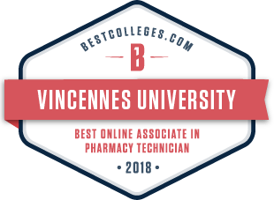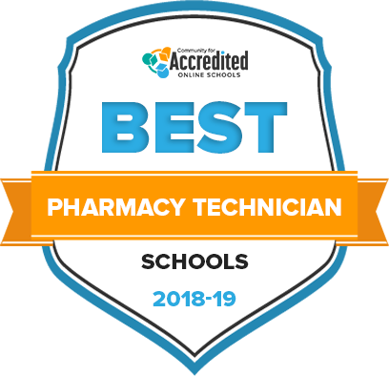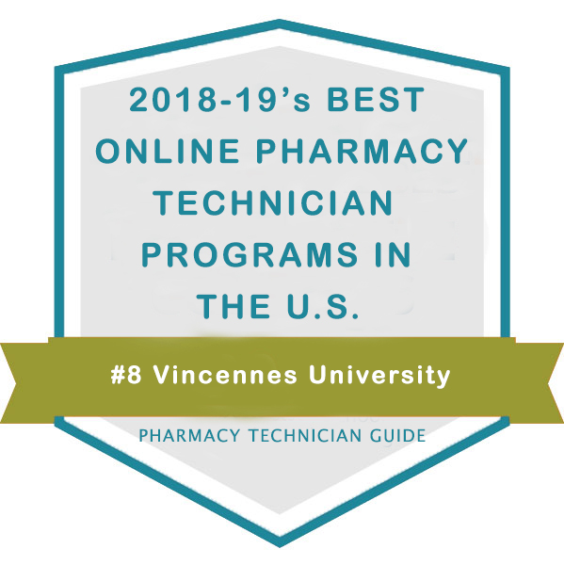
Recently Vincennes University Pharmacy Technician program has received 3 awards for Best Online Associate Degree, Best Pharmacy Technician School(s), and 2018-2019 Best Pharmacy Technician Program in the U.S.
Bestcolleges.com 2018 Award for Best Online Associate Degree:

Vincennes University’s Online Associate in Pharmacy Technology program has been recognized as one of the best in the country for 2018 by BestColleges.com, a leading provider of higher education research and college planning resources. The ranking highlights accredited, not-for-profit institutions who have developed exceptional academic online programs for students looking to advance their knowledge, skills, and career as a pharmacy technician. Bestcolleges.com’s ranking uses a methodology grounded in statistical data.
For more information please visit: https://www.bestcolleges.com/features/top-pharmacy-technician-online-training-programs/
Accreditedschoolsonline.org 2018-’19 Best Pharmacy Technician School(s) Award:

Our analysts carefully reviewed statistical data from multiple sources for more than 7,500 postsecondary institutions so that you could easily evaluate schools based on what matters most to you. For each school, we applied the eligibility criteria outlined below, then ranked schools and programs based on four ranking factors.
Eligibility Criteria for All Postsecondary Institutions:
- Must be a not-for-profit institution
- Must be regionally or nationally accredited
- Must offer at least one online program
- Must be located in a state (schools in US territories and Washington DC were not considered)

For more information please visit: https://www.accreditedschoolsonline.org/vocational-trade-school/pharmacy-technician/
Pharmacytechnicianguide.com 2018-’19 Best Pharmacy Technician Program in U.S. Award:

Vincennes University has been ranked #8 after evaluating several schools offering Pharmacy Technician programs via the online mode across the country.
The ranking was established after closely assessing the programs for the following criteria:
• Average Net Price (25%)
• Graduation Rate (20%)
• Percentage of Enrolled Students Taking Online Courses (20%)
• Loan Default Rate (20%)
• Pharmacytechnicianguide.com Rating (15%)

For more information please visit: https://www.pharmacytechnicianguide.com/Best-Online-Pharmacy-Technician-Programs.html

Insert VU-non degree seeking student application and Pharm Tech application

