TWIN RIVERS CAREER & TECHNICAL
EDUCATION AREA

FALL Counselors MEETING
September 5, 2019

- Welcome and Introductions

- Confirm Directories on TR Website – http://twinriversarea.org/directory/

- CTE Student Information Release Form – See Handout - http://twinriversarea.org/cte-release-form/

- House Enrolled Act 1002 – Non Licensed Teachers

- High School College and Career Readiness Course Titles and Descriptions – See Handout

- CTE moves to Governors Workforce Cabinet – https://www.in.gov/gwc/2431.htm

- WBL

  - Prerequisites – What is required for funding? What is required for Concentrator?
  - Must take WBL for 2 semesters
  - Reporting on INTERS this FALL
  - What does your staff need to get to me for funding?
  - Paid versus non-Paid – What is the difference with funding now and later?
  - 0530 as alternative – What has changed?

- Importance of entering Non-Funded, Spring CTE, and Online Classes on data spreadsheet

- Advisory Committee’s

  - All CTE programs need one
  - One group committee works best
  - Turn in member list
  - Turn in minutes of the meeting
  - Minutes should discuss any funds being requested
  - Syllabi from at least 1 CTE program
  - More information at http://twinriversarea.org/advisory-committee/

- Spring Recruitment 2019 – Last Year Dates and Times

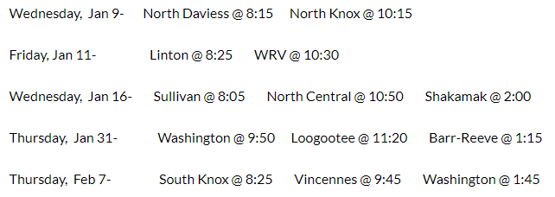

- Proposed Recruitment Dates 2019
  - ND & NK – Jan 23rd
  - Sull, NC, & Shak – Jan 29th
  - Wash, Loog, & BR – Jan 30th
  - Linton & WRV – Feb 4th
  - SK & Vin – Feb 6th

- Area Participation – What counts and what does not?

- CTE Funding

  - Fall and Spring Enrollments
  - Twin Rivers Auto, Construction, Health all $680 per credit hour or total of $2040
  - All VU/Ivy Tech programs are funded $400 or $680 per credit hour
  - CTE Courses Funding Chart – See Website
  - Data Collection Information – All info on website http://twinriversarea.org/30-a-information/
    - Directions for entering information – See Handout
    - Session Name and Code - See Website
    - Twin Rivers SPN – See Website
    - CTE Inventory List – See Website
    - Middle School Counts – 3 Courses (PCC, IED, Intro Ag)
    - Import Template – Must download new one from Twin Rivers website
    - WBL data in Fall report
    - Spring Data – What to expect?
    - Course Titles and Descriptions (specifically the pre-requisites)

- Fill out spreadsheet together

- Contact Student Management Helpdesk – Harmony, etc.

- CTE Inventory Additions for next year – Email me when you know (due July 1)

- Online Application - Google Docs

- Grade and Attendance Reporting – Any concerns?

- Dates to Remember
September 13 Count Day
September 17 30A Forms to Twin Rivers
September 21-22 IACTE – Indianapolis
October 7-11 Fall Break DKM, WBL
October 14-18 Fall Break GS, Sullivan Health
November 1 Perkins equipment requests

- Concerns/Suggestions

- Additional Discussion Items

